expense getters:

used to get the values of certain strings inputted that can’t be retrieved otherwise and might be important

expense constructor :

they’re used to create the object for expense and all the classes extended off it.

Add_expense_item():

Adds and expense object to the expenses array and does error checking

average():

calculates the average of the costs in the array

report():

prints a report of all the info in the expenses array

quit():

exits the program and prints a final report

calculate():

does the cost calculation for all the extended classes

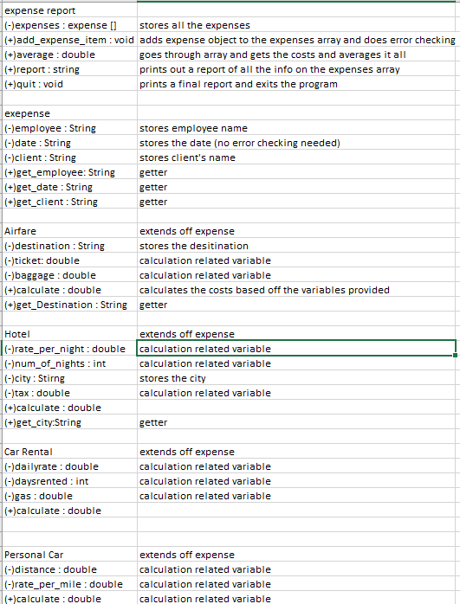

Method: add_expense_item

Purpose: add item to the expenses array

Input: expense

Return: void

Method: average

Purpose: calculate the average expense

Input: null

Return: double

Method: report

Purpose: returns a summary of all the data entered into the array

Input: void

Return: String

Method: quit

Purpose: prints a report and exits the program

Input: none

Return: void

Method: get_employee

Purpose: gets the employee name

Input: none

Return: string

Method: get_date

Purpose: gets the date

Input: none

Return: String

Method: get_client

Purpose: gets the client’s name

Input:none

Return: String

Method: calculate

Purpose: does the calculations for all the extended classes and finds out the expenses for that specific object.

Input: none

Return: double

Method: get_Destination

Purpose: gets the destination if they’re doing airfare

Input: none

Return: String

Method: get_city

Purpose: gets the city if they’re doing hotel

Input: none

Return: String